Article Title

Author Name1, Author Name2

**IMSC** requires that the authors prepare a structured abstract of more than 300 words. The abstract should include (at least) four sections: Aims, Methods, Results, and Conclusion, not necessarily separated. *Aim* study. *Methods:* systematically list the basic procedures, selection of study participants or laboratory/experimental/simulation setup, methods of observation (if applicable) and analysis. *Results*: List your primary results without any introduction. Only essential statistical significances should be added in brackets. Draw no conclusions as of yet: they belong in the next section. *Conclusion*: List your conclusions in a short, clear and simple manner. State only those conclusions that stem directly from the results shown in the paper. Rather than summarizing the data, conclude from them.

KEY WORDS

~ Maximum of

~ 6 to 8

~ Keywords

~ Relevant to

~ Article

~ Theme

1Affiliation of Corresponding Author

2Affiliation of the other author(s) – if different

e-mail: [email.of@corresponding.author](mailto:email.of@corresponding.author)

# SECTION HEADING

## Heading Level 2

### Heading Level 3

Do not use any styles or automatic formatting, except ones provided by the template itself. Fonts used for preparation of this template are widely and freely available (within scope of text editing tools such as Microsoft Work, LibreOffice, etc…)

References within article text should be written like so (Author Surname, 2015) or (Author1 and Author2, 2016). Multiple references should be separated by semicolon “**;**” within same parenthesis like so (Author, 2017**;** Author2 and Author3, 2018**;** Author 4 et al., 2019). If there are more than one reference by the same author/year, you should append latin letter a,b,c,… at the end like so (Author, 2020a; Author 2020b). Same should be applied to references list at the end of the article.

All superscripts or subscripts, symbols and math relations and equations should be written in MathType or Equation editor.

${\left(x+a\right)}^{n}=\sum_{k=0}^{n}{\left({n \atop k}\right)x^{k}a^{n-k}}$…………………………….(1)

Information of significance and other statistical data should preferably be given in the tables and figures. Tables should bear Arabic numerals. Each table should be self-explanatory, with an adequate title (clearly suggesting the contents), and logical presentation of data. The title should preferably include the main results shown in the table. Use tables in order to present values of data that cannot be summarized in a few sentences of the text.

|  |  |  |  |
| --- | --- | --- | --- |
|  | Column 1 | Column 2 | Column 3 |
| Row 1 | Some data | Some other data | 1234 |
| Row 2 | Further data | etc… | 5678 |

Table 1. Tables should have descriptive names and be numbered in sequence with Arabic numerals (Source: You can also provide source for your data here.)

Figures should also be numbered in sequence with Arabic numerals. Minimum resolution for all types of graphics is 300dpi (but 600 dpi is preferred and encouraged). You might be asked by production editors to provide graphic sources separately from the manuscript in later stages of submission workflow.

If you are using graphs as figures, please do so in xls/xlsx format. (Excel or similar graph embedded in this template). Low resolution graphs and charts saved as raster image (gif, jpeg, png) imported copy/pasted into template are not acceptable.

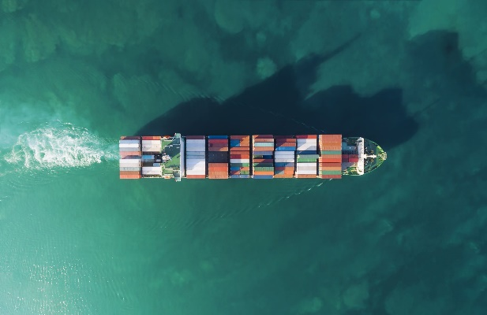

Figure 1. Example of figure representing ship underway (Source: Microsoft Office stock images).

Please make sure you own license rights to pictures/photographs or you used public domain (free) illustrations.

**ACKNOWLEDGEMENTS:** Following conclusion of your article, you can provide acknowledgements for your research / writing of the article / support / etc… This paragraph is optional and can be deleted from your submission.

**Conflict of interest:** Following conclusion of your article, you should also declare Conflict of Interest, if any. This paragraph is mandatory.

References

Author, A. & Author, B., 2016. Book name, 1st Edition, Place of publishing: Publisher. Available at: <http://dx.doi.org/123.456-abcd>.

Author, C.D. et al., 2015. Name of The Article. Name of the Journal, 9(25). Available at: <http://dx.doi.org/789.012-efgh>.

Web Site, 2000. Name of the Web Page. Available at: <https://link.to.the.web.page>, accessed on: date of access.

These are just a few examples of citation and references styles**. IMSC** uses Harvard citation and reference style. **Usage of DOI (digital object identifier links) is mandatory**. You can check/find DOI links for specific references on the official CrossRef Metadata Search webpage: <https://search.crossref.org>

References list should be sorted alphabetically.

Should you have any other questions, feel free to contact **IMSC** tech support contact.